**Fronted Development with React .js Project Dcoumentation format.**

**Rhythmic Tunes : Your Medolic Companion**

## 1.Introduction

**Project Tittle: Rhythmic Tunes:Your Melodic Companion**

**Team Member:**

**Team Leader Name : PAVITHRA.A**

**Team Member Name :RAMYA.S**

**Team Member Name : PRITHIKA.G**

**Team Member Name:DHANALAKSHMI.M**

**Team Member Name:MYTHILI.M**

#### 2. Project Overview

**Purpose :**

**Rhythmic Tunes is a modern music streaming application designed to offer users an immersive listening experience.It provides a vast collection of songs ,playlists, and personalized recommendations. The app ensures a seamless interface for browsing ,discovering,and enjoying music.**

**Freatures:**

**\*personalized playlist creation**

**\*Browse songs by genre, artist,or album**

**\*search functionality with real-time suggestion**

**\*media player with play/pause,next/previous,and volume control**

**\*book mark feature for saving favorite tracks**

**\*lite /dark mode for improved user experience**

**\*responsive design for desktop and mobile device**

3.Architecture

**component structure;**

**APP.JS-root component managing layout and routing**

**Header.js-nevigation bar with search functionality**

**Songlist.js-displays a list of available songs**

**Songcard.js-individual card showing songs details and controls**

**Playlist.js-manages user –created playlists**

**Media player.js-provides audio playback controls**

**Footer.js-displays copyright and app links**

**State management**

**Context API-used for managing global states such as theme preferences ,playlist data ,and bookmarked songs**

**Routing ;**

**React Router-implemented for seamless navigation between music categories ,playlist views,and song details**

## 4.Setup Instructions

**Prerequisites:**

**-Node.js(v18 or higher)**

**-npm or yarn**

**Installation :**

**1.clone the repository:**

**‘’’bash**

## **git clone** <https://github.com/darunraj0071/rhythmic-tunes.git> **cd rhythmic-tunes**

‘’’

**2.Install dependencies:**

**‘’’bash**

**npm install**

**‘’’**

**3.Create ‘.env’ file (for API keys or environment variables):**

**‘’’env**

**REACT _APP_MUSIC_API_KEY=your_api_key_here “’**

**4.Run the application :**

**‘’’bash**

**npm start**

**‘’’**

## 5.Floder Struture

**/src**

**\*/Components**

**\*Header.js**

**\*SongsList.js**

**\*Playlist.js**

**\*Media Player.js**

**\* Footer.js**

**\*/pages**

**\*Home.js**

**\*Discover.js**

**\*Playlist.js**

**\*Favorites.js**

**\*/assets**

**\*image**

**\*icons**

**\*styles**

**\*/utils**

**\*api.js**

**\*helpers.js**

**\*constants.js**

**\*app.js**

**\*index.js**

6.Running the application

**Frontend Server Command:**

**‘’’’bash**

**Npm start**

**‘’’**

7.Component Documentation

**Key components:**

**Header: Provides navigation,search functionality,and theme toggling**

**SongList: Displays categorizedbor searchedbsongs in a structured format**

**Song Card: Displays individual song details with play/ pause control**

**Reusable Component:**

**Model Component: Dispalys songs details or playlist creation forms**

**Button Component: Used for action like “Play,”Pause,”or Add to Playlist”**

8. State Management:

**Global State: Managed via Context API for bookmarks,plalists , and theme control**

**Local State: Managed using Reacts’s useState()’for track progress ,user interaction,and dynamic updates**

9. User Interface

**Clean ,minimalistic UI designed for seamless navigation**

**Fully responsive Layout with smooth transitions**

**Light/Dark mode toggle for personalized visual comfort**

10.Styling:

**CSS Frameworks/Libraries:**

**Tailwind CSS- Used for fast and modern UI design**

**Theming:**

**Integrated theme switcher for enhanced user experience**

11. Testing

**Testing Strategy:**

**Jest for unit testing**

**React Testing Library for comprehensive component testing**

**Code Coverage:**

**Ensured high code coverage with jest reports**

12.Screenshots or Demo

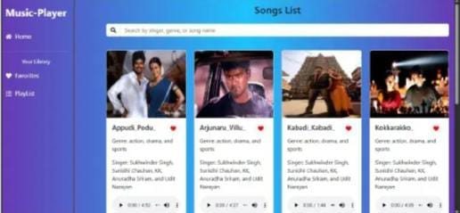

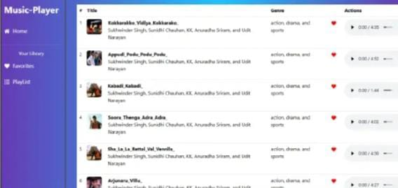

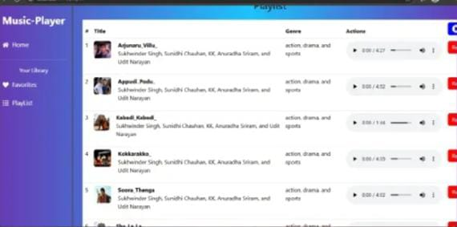

13.Known Issues

**Occasional delays in song loading due to API limits**

**Playlist feature may require additional optimization for large data sets**

14.Future Enhancements

**Implement User authentication for personalized playlists**

**Introduce Podcast and radio streaming integration**

**Social Sharing feature for tracks and playlists**

**Offline mode for saved playlists without an internet connection.**